Board Bot 2021

Fatimah | Hussain Nazir
Department of Electronics Engineering  Ghulam Ishaq khan Institute of Engineering and Sciences  Topi, Swabi 23430, Pakistan  u2016130@giki.edu.pk | Department of Electronics Engineering  Ghulam Ishaq khan Institute of Engineering and Sciences  Topi, Swabi 23430, Pakistan  u2018152@giki.edu.pk
Asma Waheed | Hamza Nadeem
Department of Electronics Engineering  Ghulam Ishaq khan Institute of Engineering and Sciences  Topi, Swabi 23430, Pakistan  u2018086@giki.edu.pk | Department of Electronics Engineering  Ghulam Ishaq khan Institute of Engineering and Sciences  Topi, Swabi 23430, Pakistan  u2018133@giki.edu.pk

Abstract – Board bot is a vertical XY plotter that executes texts and images on a board with the help of a marker.

Index Terms – XY Plotter, Arduino, grbl, PCB

I. Introduction
XY Plotter is an embedded system that works based on the principal Computer Numerical Control. XY Plotter basically works with two stepper motors and a servo motor, wherein the robot plots the input given from the computer on the drawing board using a microcontroller on a open-source physical computing platform Arduino. The XY plotter has a two-axis control and a special mechanism to raise and lower the pen. Each axis is powered and driven by using an Arduino compactable driver. The plotter works more efficiently, which is used to recording or plotting two-dimensional data on a rectangular coordinate system. In this, Arduino compatible main board with two stepper motors for ease moving of pen holder and servo motor is used to lift the pen. For this we are using the software like Arduino IDE software and G code converter. This improves the efficiency which produces large and complex drawings.
II. Literature Review
Robotic 2D Plotter is a plotter that offers the fastest way to efficiently produce very large drawings. Pen plotters will be able to print by moving a pen or other writing device across the surface of a piece of paper. This means that plotters are vector graphics devices. Pen plotters can draw complex line art, including text, but do so slowly because of the mechanical movement of the writing device such as pen.
The Arduino based Board Bot uses atmega 328 microcontroller which is used to draw fast and efficient drawings or pictures which can be taken from source converted to scalar vector graphics (SVG) format given as a input. The input is fed into the input port of the micro controller. Stepper motors are used to set the position of the pen to the origin and a servo mechanis1m used to lift and lower the which displays the output on the paper.
GRBL with CNC shield is used to obtain vector graphics and drive the motors and in turn the pen for drawing of images.
GRBL is a firmware for Arduino boards (uno, nano, Duemillanove) that controls stepper motors. GRBL uses gcode as input and outputs signals via the Arduino pins. Most industrial CNC machines use parallel port controller that requires Those big purple connectors.
The Computer Numeric Control (CNC) shield itself consists of a board with Motor drivers that are used to control motors. The motor drivers correspond to the X-, Y-, and Z-axes. An additional motor driver may be added for a fourth axis called ‘A’. For a typical 3-axis CNC router, the X-motor controls the movement of the router bit for the X-axis (from left to right), the Y-motor controls the Y-axis movement, and the Z-motor controls the height. It’s through a combination of these motors that the CNC router can carve out three-dimensional shapes from a piece of stock material like wood, plastic, or steel.
Motor driver or Motor Driver IC(A4988) which allows DC motor to drive on either direction, which can control a set of two DC motors simultaneously in any direction.
Servo motors (SG90) are an easy way to add motion to your electronics projects. Originally used in remote-controlled cars and airplanes, they now crop up in all sorts of other applications. They are useful because you can instruct these small motors how far to turn. The motor is paired with some type of encoder to provide position and speed feedback. In the simplest case, only the position is measured. The measured position of the output is compared to the command position, the external input to the controller. If the output position differs from that required, an error signal is generated which then causes the motor to rotate in 6 either direction, as needed to bring the output shaft to the appropriate position. As the positions approach, the error signal reduces to zero and the motor stops.

III. Technical specifications
- Micro Controller Arduino UNO
Operating Voltage | 5V
Input Voltage (recommended) | 7-12V
Input Voltage (limit) | 6-20V
Digital I/O Pins | 14
PWM Digital I/O Pins | 6
Analog Input Pins | 6
DC Current per I/O Pin | 20 mA
DC Current for 3.3V Pin | 50 mA
Flash Memory | 32 KB
SRAM | 2 KB
EEPROM | 1 KB
Clock Speed | 16 MHz
LED_BUILTIN | 13
Length | 68.6 mm
Width | 53.4 mm
Weight | 25 g

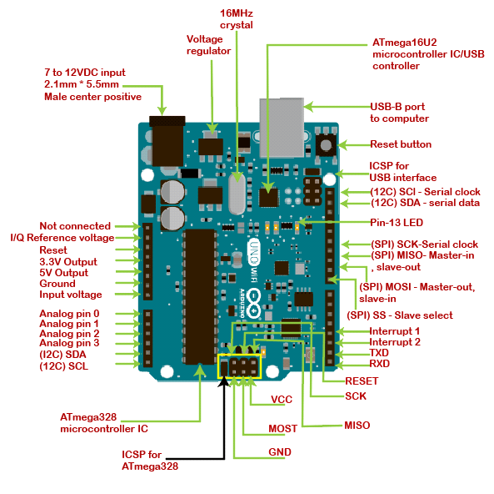Fig. 1 Arduino Uno

- Stepper Motor NEMA 17
Rated Voltage: 12V DC.
Current: 1.2A at 4V
Step Angle: 1.8 deg.
No. of Phases: 4
Motor Length: 1.54 inches
4-wire, 8-inch lead
200 steps per revolution, 1.8 degrees
Operating Temperature: -10 to 40 °C
Unipolar Holding Torque: 22.2 oz-in

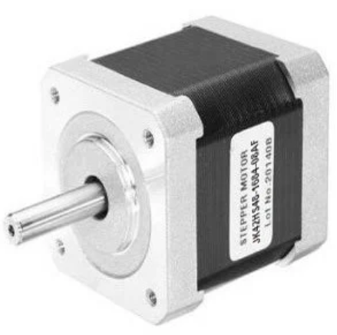
Fig. 2 Stepper Motor Nemo

- Motor Driver A4988
Minimum operating voltage: | 8 V
Maximum operating voltage: | 35 V
Continuous current per phase: | 1 A
Maximum current per phase: | 2 A
Minimum logic voltage: | 3 V
Maximum logic voltage: | 5.5 V
Micro step resolutions: | full, 1/2, 1/4, 1/8, and 1/16
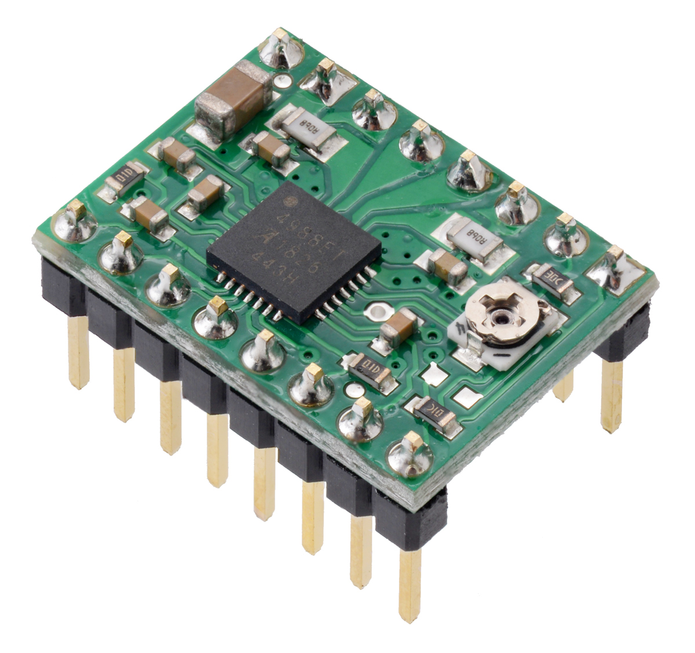
Fig. 3 Motor Driver

- Servo motor SG90
Operating Voltage is +5V typically.
Torque: 2.5kg/cm
Operating speed is 0.1s/60°
Gear Type: Plastic
Rotation: 0°-180°
Weight of motor: 9gm

Table 1.1
Wire Number | Wire Colour | Description
1 | Brown | Ground wire connected to the ground of system
2 | Red | Powers the motor typically +5V is used
3 | Orange | PWM signal is given in through this wire to drive the motor

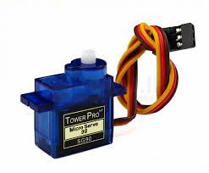
Fig. 4 Servo Motor

- CNC Shield

Uses removable A4988 compatible stepper drivers.
Jumpers to set the Micro-Stepping for the stepper drivers.
Stepper Motors can be connected with 4 pin molex connectors or soldered in place.
Runs on 12-36V DC.
Latest Arduino CNC Shield Version 3.10
GRBL 0.9 compatible. (Open-source firmware that runs on an Arduino UNO that turns G-code commands into stepper signals)
PWM Spindle and direction pins
4-Axis support (X, Y, Z, A-Can duplicate X, Y,Z or do a full 4th axis with custom firmware using pins D12 and D13)
2 x End stops for each axis (6 in total)

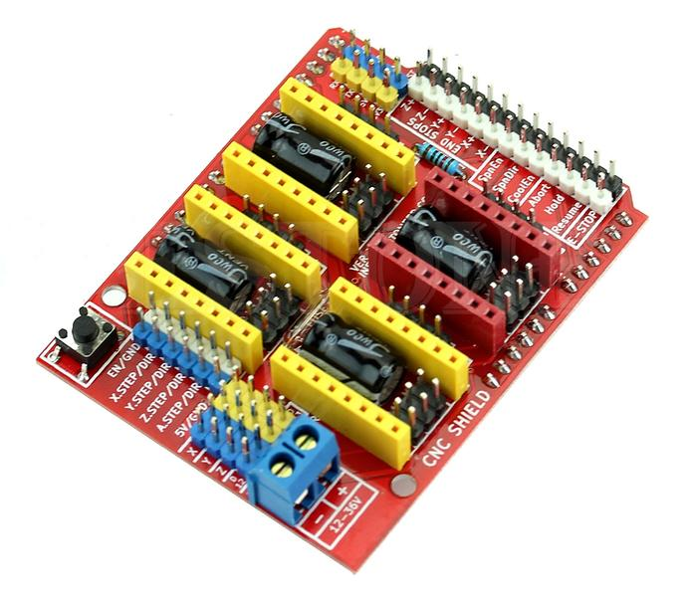
Fig. 5 CNC Shield

IV. DIGITAL MODEL

- 3D Modelling
The software used to make 3D models of this project is Solid Works. The following attached screenshots are the top view, side view and front view of the hardware design.

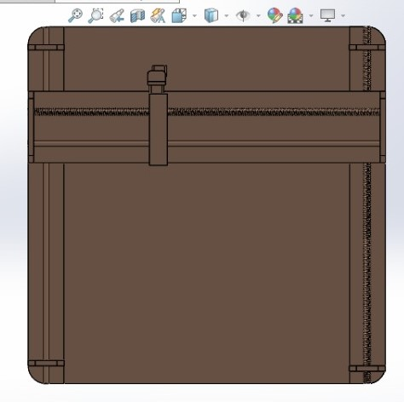
Fig.6 Top View

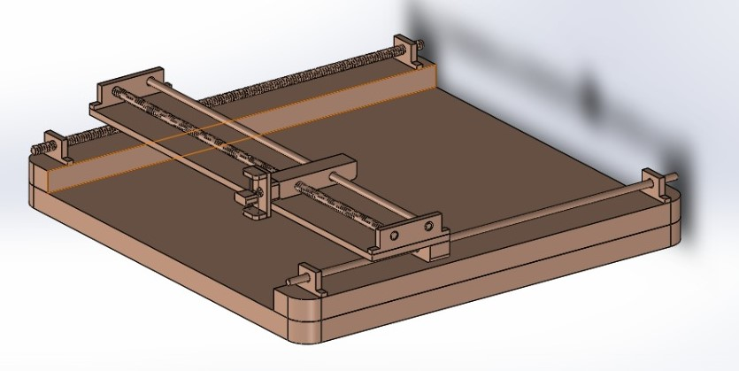
Fig. 7 Side View
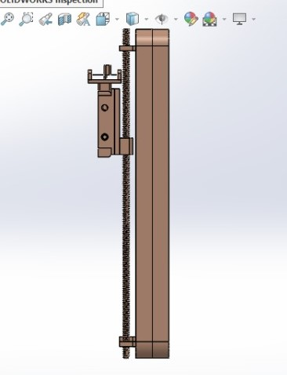
Fig. 8 front view

- 2D Modelling
For the overall better understanding a 2D model of the hardware is all attached, this 2D model representation was provided to the manufacturer for the development of the hardware.

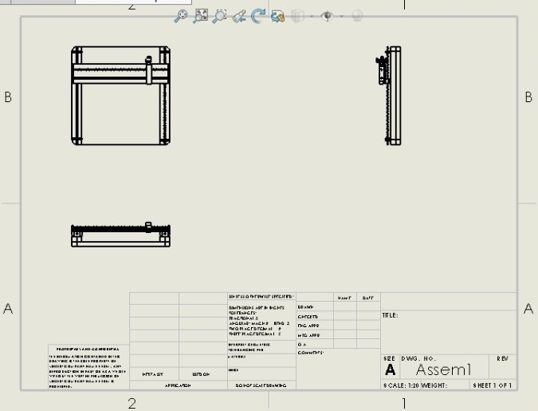
Fig. 9 2D Model

V. Circuit Diagram
The circuit diagram here explains all the connection between all the hardware components of the Board Bot i.e., Arduino, CNC shield, and servo motors. Jumper wires to do all the shown connections and have been soldered where required.

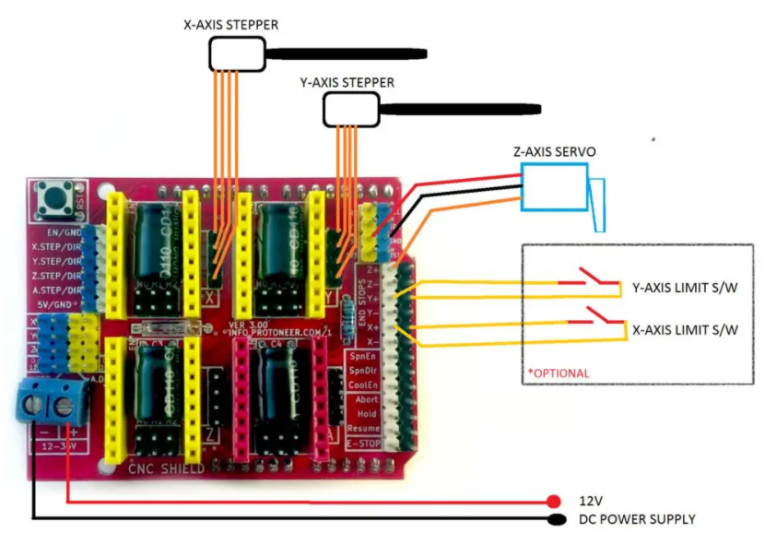
Fig. 10 Circuit Diagram

VI. Flow Chart
The flowchart below can easily explain the whole Board Bot. It tells how different software and components of hardware process and work together to produce the desired output image, in form of a text or image. There are 8 different steps of the flowchart that are followed to achieve the desired results.

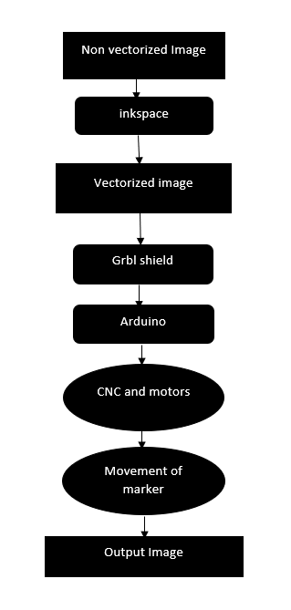
Fig. 11 Flow Chart

VII. Working
Board Bot works on the basic principle of the plotter. A plotter printer is a term for printers that are used for printing vector graphics. A computer hardware device that uses stationery writing tools to draw continuous lines on media papers rather than a series of dots like a traditional toner printer. If we further characterize our project, it specifically comes under the XY plotter in which has a two-axis control and a special mechanism to raise and lower the pen. Each axis is powered and driven by using an Arduino compactable driver.

VIII. Conclusion
The primary goal of this project was to find & build a cheaper and mass producible design of a Board Bot XY Plotter maintaining the accuracy as well. This project is further extendable. Modification of pen holder component can make this project suitable for a lot of applications. We tried our best in designing and implementing this model. Our lack of expertise & experience, manual fabrication of various parts sometimes hindered our progress and affected the perfection to be attained. Overcoming these obstacles and reaching the fruition was a wonderful experience for us.

References
- M. King, B. Zhu, and S. Tang, “Optimal path planning,” Mobile Robots, vol. 8, no. 2, pp. 520-531, March 2001.
- H. Simpson, Dumb Robots, 3rd ed., Springfield: UOS Press, 2004, pp.6-9.
- M. King and B. Zhu, “Gaming strategies,” in Path Planning to the West, vol. II, S. Tang and M. King, Eds. Xian: Jiaoda Press, 1998, pp. 158-176.
- B. Simpson, et al, “Title of paper goes here if known,” unpublished.
- J.-G. Lu, “Title of paper with only the first word capitalized,” J. Name Stand. Abbrev., in press.
- Y. Yorozu, M. Hirano, K. Oka, and Y. Tagawa, “Electron spectroscopy studies on magneto-optical media and plastic substrate interface,” IEEE Translated J. Magn. Japan, vol. 2, pp. 740-741, August 1987 [Digest 9th Annual Conf. Magnetics Japan, p. 301, 1982].
- M. Young, The Technical Writer’s Handbook, Mill Valley, CA: University Science, 1989.

